

**For Immediate Release**

Media Contact: Christine Duggan

cduggan[@flexoconcepts.com](mailto:ghowell@flexoconcepts.com)

**Flexo Concepts® to Join Guangzhou Jiaqi in Promoting TruPoint Orange® Blade at Lithium Battery Show in Shenzhen**

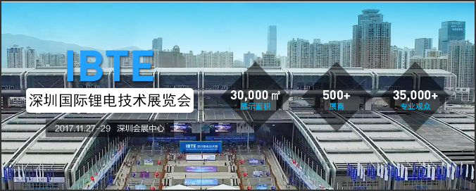[](https://www.google.com/url?sa=i&rct=j&q=&esrc=s&source=images&cd=&cad=rja&uact=8&ved=0CAMQjRw&url=https://www.siegwerk.com/en/news/press-releases/details/new-cooperation-between-siegwerk-scandinavia-and-rr-print.html&ei=1nyNVfTNI8j1-QHyuKeQDw&bvm=bv.96782255,d.cWw&psig=AFQjCNGSpZlsBmZY6O3qZEizpiQkQlX-VQ&ust=1435422294636357)

**Plymouth, MA, November 21, 2017.** Flexo Concepts just announced that it will join with industry partner, Guangzhou Jiaqi, at the International Lithium Battery Technology Exhibition 2017 (IBTE) in Shenzhen, China, November 27-29. The companies will share booth space and promote the TruPoint Orange doctor blade in the fast-growing Asian lithium ion battery market.

In this application, TruPoint Orange blade can be used to apply the coating of the lithium ion battery separator film. A precise lay-down of coating improves the mechanical properties and thermal stability of the film, facilitating the charge and discharge of the battery while preventing short-circuiting. Steve Kao, Flexo Concepts’ Asian Key Account Manager, will be available to explain the benefits of using Orange and offer samples.

Held concurrently with the South China International Lithium Battery Summit Forum, the IBTE show is the largest exhibition of its kind in southern China. The event hosts more than 500 exhibitors, in a 30,000-square meter exhibition hall, and attracts more than 35,000 visitors. For more information about the show, visit http://www.ibtechina.com/.

To learn more about TruPoint Orange doctor blades in this application or to obtain a sample, visit Flexo Concepts at IBTE at stand 7B71. To access a complete press kit, go to http://www.flexoconcepts.com/media.

**About Flexo Concepts**

Headquartered in Plymouth, Massachusetts, Flexo Concepts manufactures TruPoint® doctor blades and wash-up blades and MicroClean™ dry media anilox cleaning systems. All products are designed to improve print quality and reduce operational costs for flexographic and offset printers. Flexo Concepts maintains distribution locations in North America, South America, Europe, Asia, Africa and Australia. For more information about the company and its products visit http://www.flexoconcepts.com/. For regular updates, follow Flexo Concepts on Facebook and Twitter.